Fort Kent Bicycle and Pedestrian Plan

June 2014

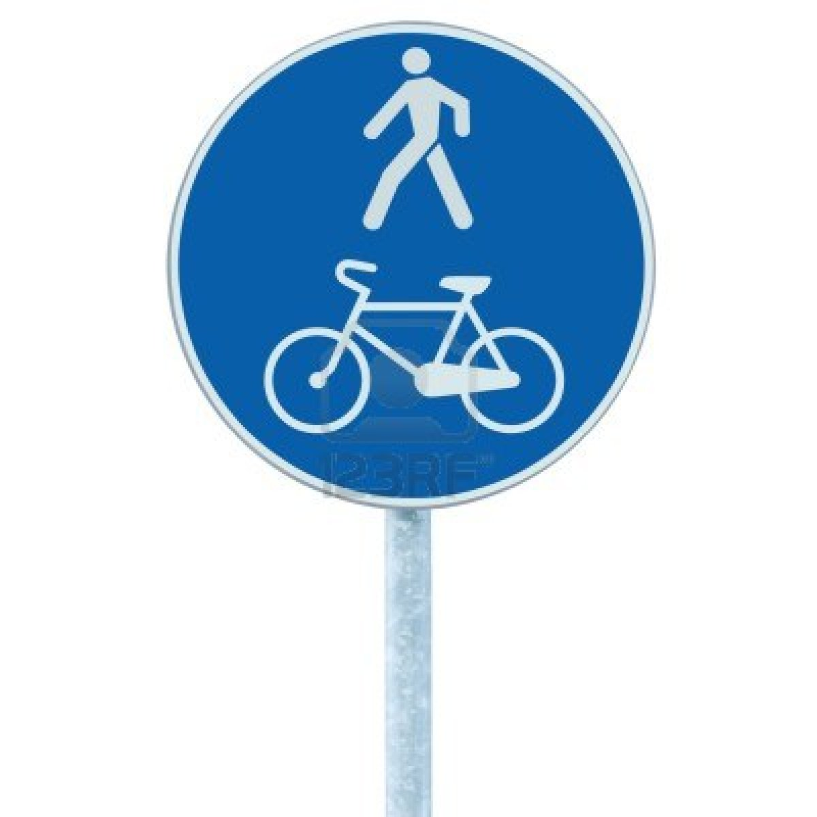
Table of Contents

Introduction 1

Bicycle and Pedestrian Advisory Committee 1
Convening Members of the Advisory Committee 1
Partners, Staff and Interested Individuals and Organizations 2
The Planning Process 2

Fort Kent-The Community 3

Local and Regional Trail Systems 4
Fort Kent Trails System 5

Coordination with Existing Plans 5
Fort Kent Comprehensive Plan 6
Fish River Scenic Byway and Corridor Management Plan 6
International Bridge Improvements 7
St. John Valley Scenic Byway Corridor Management Plan 7
Fort Kent Downtown Plan 7

Existing Plans and Ordinances and Budgeting 7

Existing Conditions 8
Conditions-Sidewalks 8
Safety Concerns 11

Goals, Objectives, and Strategies 11
Pedestrian/Bicycle Vision for Fort Kent 11

Proposed Bicycles and Pedestrian Facilities and Services 17
Criteria for Selecting Projects 17
High Priority Investments 17

Next Steps 19

Introduction

The Town of Fort Kent, Maine Department of Transportation, Power of Prevention, and the Northern Maine Development Commission began a bicycle and pedestrian planning exercise in December 2012 with the intention of defining projects and programs needed to make Fort Kent a bike- and walk-friendly community. The Bicycle and Pedestrian Advisory Committee, made up of residents with a wide range of interests, was formed to assist with the development of the plan. The committee, with the assistance of town officials and through the review of a resident survey identified no/low cost projects that the community can accomplish while seeking to create biking and walking opportunities during all four seasons. The plan also contains projects that are more expensive and longer term. These projects will be considered as funding becomes available

Readers of the Fort Kent Bicycle and Pedestrian Plan are encouraged to get involved with local leaders, schools, bike clubs, exercise groups and neighbors to encourage policies, programs and projects that will allow everyone to move about safely on foot, bike, roller skates, roller skis, skateboard and wheelchair.

The time frame envisioned for implementation of this plan is ten years. The Fort Kent Planning Department will work with the Recreation and Roads Committees as well as other interested parties toward successful implementation of the plan and on periodic review of the plan’s goals and objectives.

The list of projects, ranging from simple signs and markings, and improved sidewalks and crosswalks, to major trail development, including surfaces, lighting and benches, were prioritized. For example, identification of safe walking/bicycling routes between places where people live, work, go to school, and play, will be a first step. Safety improvements, sidewalks, signs, maps, and designated trails that connect existing facilities such as 10th Mountain and the recently constructed senior center, may be suggested to encourage "active" (vs. motorized) transportation. The potential of a complete "Fish River Greenway” trail along both sides of the river in town will be examined. The plan will offer action steps and suggest potential funding sources to enable the plan projects to become a reality that will improve the pedestrian and bicyclist environment in Fort Kent.

Bicycle and Pedestrian Advisory Committee

The Bicycle and Pedestrian Advisory Committee was formed for the purpose of creating this plan.

Convening Members of the Advisory Committee
Name | Affiliation
Donald Audibert | Bicyclist/Jogger
Julie Daigle | Power of Prevention
Joseph Davis | Power of Prevention
Jeff Dubis | University of Maine at Fort Kent/10th Mountain Ski Club
Frances LaBrie | Pedestrian, interested resident
Matthew Michaud | Bicyclist
Raymond Phinney | University of Maine at Fort Kent
Tony Theriault | Public Works Director

Partners, Staff and Interested Individuals and Organizations
Joanne Fortin | Northern Maine Medical Center
Karen Boutot Gorman | Power of Prevention
Jay Kamm | Northern Maine Development Commission
Peter Saucier | S.A.D. #27/Transportation Supervisor
Steve Pelletier | Fort Kent Planning and Economic Development Director
Michelle Plourde-Chasse | Community Voices
The committee began by agreeing to a statement describing their mission.

Mission: To identify no/low cost projects that the community can accomplish while seeking to create biking and walking opportunities during all four seasons.

The Fort Kent Bicycle and Pedestrian Plan is a dynamic document that will be evaluated and updated continually to meet changing conditions and priorities. In order for this plan to be implemented and updated, the Town of Fort Kent empowers the planning department to work with municipal committees to provide advice, logistical support and coordination with other public works and planning initiatives.

The Planning Process

The following summarizes the steps that were taken during the planning process. The planning process included committee meetings where ideas were discussed, priorities stated, hand drawn maps were created and decisions made, and back office analyses where staff planners assembled data, created maps and summarized committee proposals.

1. Bicycle and Pedestrian Advisory Committee Support
1: Recruit committee members
2: Prepare agenda and minutes
3: Facilitate meetings
4: Respond to information requests

2. Summary of Maine Programs
1: Gather information
2: Create summary report
3: Report findings to committee
3. Update Infrastructure Maps
1: Create baseline GIS Maps
2: Conduct field survey with GPS
3: Prepare updated GIS Maps
4. Integrate Policies
1: Review existing documents
2: Prepare draft synthesis
3: Present draft for comments
4: Prepare final policy synthesis
5. Create Bicycle and Pedestrian Plan
1: Public Involvement
2: Goals-Objectives-Strategies
3: Draft Document
4: Revise Document
5: Final Draft

Fort Kent-The Community

Fort Kent is a picturesque town which provides services for residents of many smaller, outlying towns, and is located in Northern Maine on the Canadian border. The town has a rich Acadian heritage. The area provides a variety of tourist attractions with some of the best snowmobiling in the state, excellent ATV trails, 10th Mountain and Lonesome Pine ski and outdoor recreation clubs, and excellent hunting and fishing. Fort Kent is known as the “Little Town That Could” with a reputation for thriving under circumstances that are challenging, and for the community’s spirit of willing volunteerism. Also unique to the community is that students can complete pre-K through college along a ¼ mile stretch of street. The economy is driven by forestry, agriculture and tourism, with the majority of occupations in sales, management/professional services, health services, farming/forestry, construction, production, and transportation.
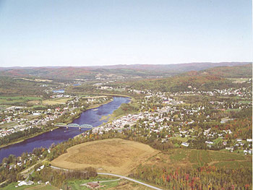

Geography:

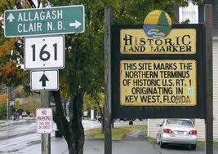
Fort Kent is a Northern Maine border town and is economically and culturally linked to the Canadian towns of Clair and St. Francois, New Brunswick, across the St. John River. Sixty-two percent of Fort Kent’s residents are native speakers of French. The variety of French spoken in Fort Kent and most of the St. John River Valley closely resembles the French spoken in neighboring New Brunswick Canada and somewhat resembles the French spoken in nearby Quebec. Fort Kent is the beginning of U.S. Route 1, which is also known as America’s First Mile. America’s First Mile has been registered as a marketing brand, and is utilized to promote Fort Kent’s many resources and market the downtown in order to entice new business. According to the United States Census Bureau, the town has a total area of 55.51 square miles. Its nearest major cities are Presque Isle, Maine, 56 miles away, and Edmundston, New Brunswick, 20 miles away. The two major highways in town are U. S. Route 11 and Route 161.

Demographics:

Population: | 1990 | 2000 | 2010
Fort Kent | 4,268 | 4,233 | 4,097
Aroostook County | 86,936 | 73,938 | 71,870

Local and Regional Trail Systems

Fort Kent has an extensive network of mapped trails and access points for land- and water-based recreation during all seasons. Snowmobile and ATV trail information and maps are readily available from the Association of Aroostook Chambers of Commerce, visitaroostook.com and at most Chamber of Commerce offices. The 2,200 mile snowmobile trail system is maintained by about 40 local clubs and the 1,200 mile ATV trail system is maintained by about 28 local clubs. Hiking, mountain biking and canoe/kayak trails are available throughout the region and include Aroostook State Park, the Allagash Wilderness Waterway, North Maine Woods, Maine Public Reserve Lands and others. There are 31 mapped water trails in the region that comprise about 250 miles for paddling. Trails and trail information are supported by many public and private entities. Detailed information is available online at several locations including GoArostookOutdoors.com and the North Maine Woods and Maine DOC websites.

The Northern Forest Canoe Trail is a long-distance paddling trail connecting the major watersheds across the Adirondacks and Northern New England. The 740-mile water trail traverses across New York, Vermont, Quebec, New Hampshire, and Maine. The trail terminates in Fort Kent at the landing located at the confluence of the Fish and St. John Rivers.

The following table summarizes the local trail networks located in the Fort Kent area.

Fort Kent Trails System

Trail System | Length | Uses
10th Mountain Center | 20 miles | Cross country skiing, snowshoeing, hiking, mountain biking, roller skating, roller skiing
Heritage Trail | 20 miles | Multiuse
Riverside North | 0.26 miles | Hiking, mountain biking
Riverside South | .75 miles | Hiking, mountain biking and snowmobiling
Snowmobile (various) | 33 miles | Snowmobiling (and dog sledding)
The Mills Loop | 3 miles | Walking, biking
Fish River (Soldier Pond to Fort Kent) | 10 miles | Canoeing and kayaking
St. John River (Allagash to Fort Kent) | 26 miles | Canoeing and kayaking
Northern Forest Canoe Trail Terminus | 5.5 miles | Canoeing and kayaking
Fish River Falls | .40 miles | Hiking, snowshoeing
ATV Trail System | 24 miles | ATV riding, mountain biking
Island Trail | 0.42 miles | Hiking, mountain biking
Lonesome Pine trails | N/A | Alpine skiing, snowboarding, hill repeats
Jalbert Park trail | 0.43 miles | Hiking, mountain biking
Crocker Beach trail | 0.32 miles | Hiking, mountain biking
Levee trail | 0.65 miles | Hiking, mountain biking
Riverside West | 0.42 miles | Walking, biking
Riverside Park | 0.31 miles | Walking, biking
Proposed- Fish River Greenway | TBD | Multiuse
Source: Town of Fort Kent, Northern Maine Water Trail Map 7 Guide, Northern Forest Canoe Trail website, ATV/Snowmobile Clubs, 10th Mountain Center, 2012

Coordination with Existing Plans

A number of transportation related projects and plans are underway in Fort Kent. The committee recognized the importance of coordinating this document with these existing programs. The following plans are particularly significant with respect to planning for bicycle and pedestrian access:

- Fort Kent Comprehensive Plan
- International Bridge Improvements
- St. John Valley Scenic Byway Plan
- Fish River Scenic Byway Plan
- Downtown Plan

Fort Kent Comprehensive Plan

Fort Kent’s 2012 Comprehensive Plan is a unified document governing many other “plans” that follow in this report. The plan includes information identifying pedestrian and bicycle infrastructure and issues, and sections outlining related transportation goals and objectives.
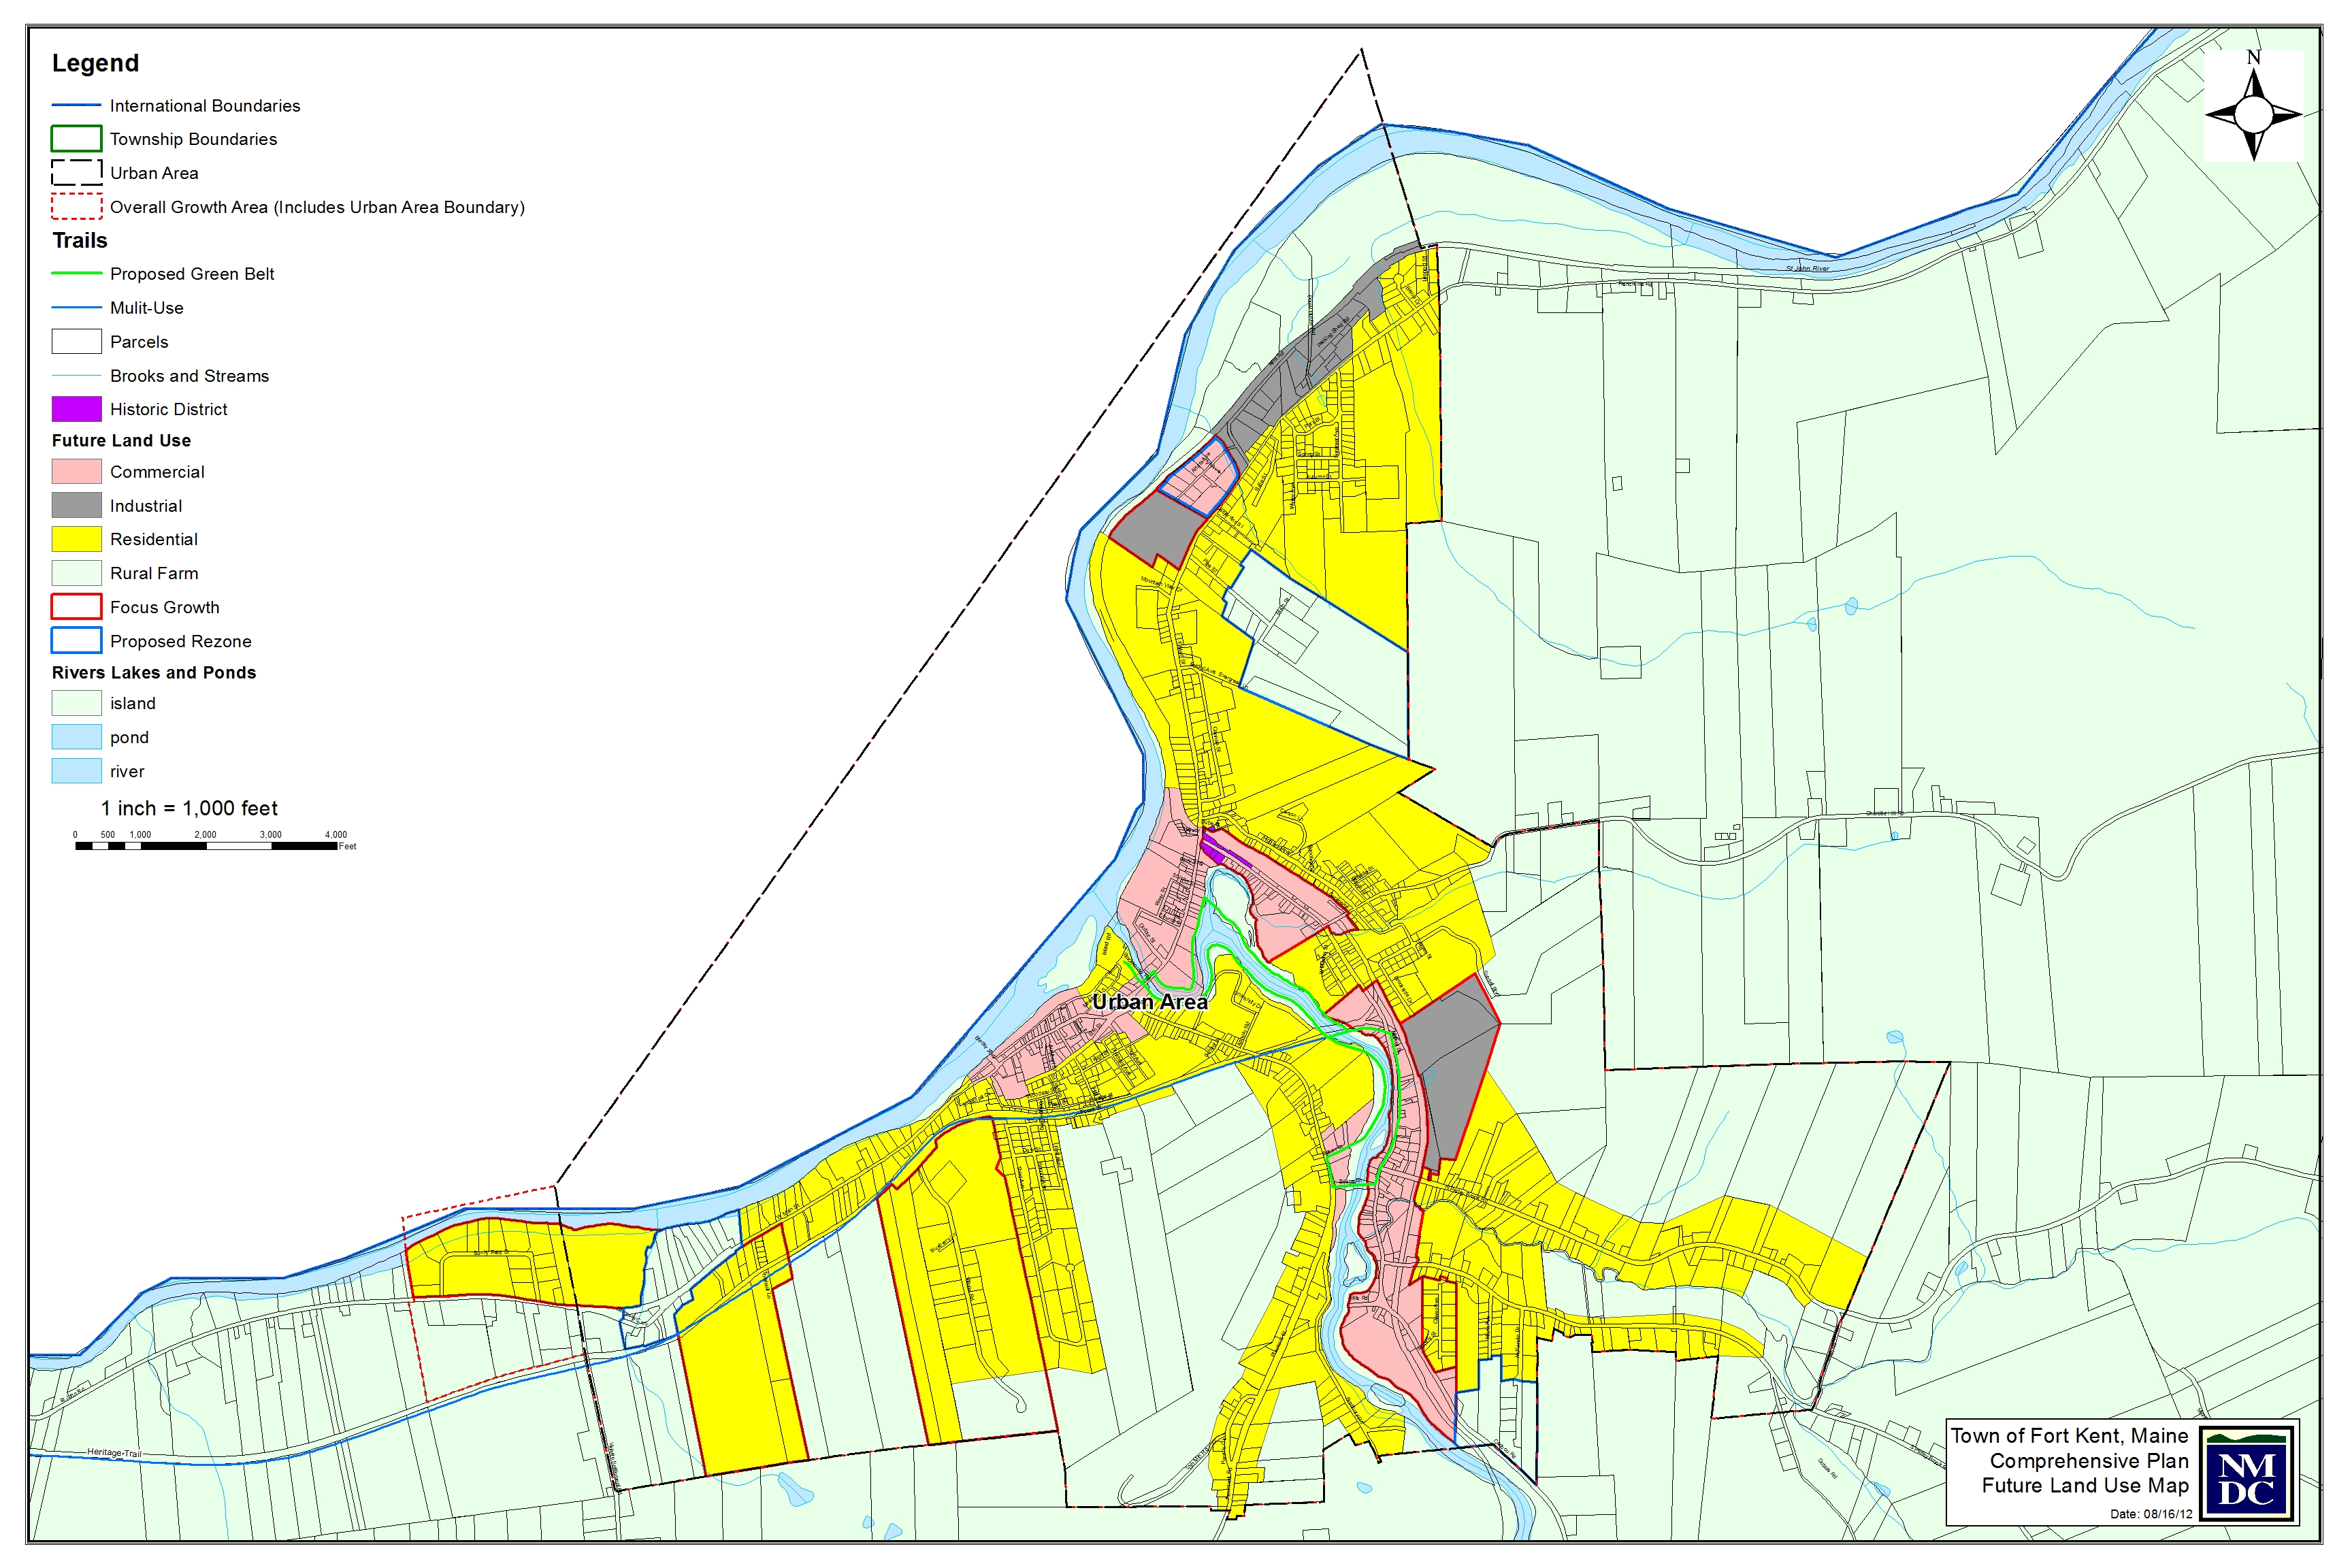

Highlights of the plan include:
- Creating a dedicated pedestrian/
bike trail using the Fish River Greenway concept or other suitable locations
- Encouraging the town and school to place bike racks in appropriate locations around town
- Encouraging complete bike and walkability studies of the town.
- Providing safe and convenient bicycle and pedestrian access to the downtown, neighborhoods, schools, and businesses.

Fish River Scenic Byway Corridor Management Plan

The 2007 Fish River Scenic Byway Corridor Management Plan works to identify, preserve, maintain and enhance scenic, cultural, historic, and recreations resources located along the Fish River Scenic Byway (Route 11) located between Fort Kent and Portage Lake. The plan’s strategies include:

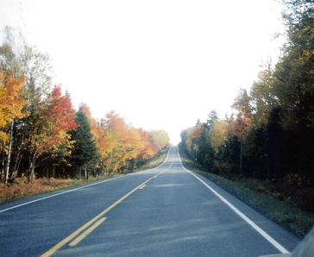
- Encouraging safety programs for bicyclists and pedestrians
- Encourage the creation of safe local bike and pedestrian routes
- Maintaining areas that are dangerous due to low shoulders and poor geometrics or other areas

International Bridge Improvements

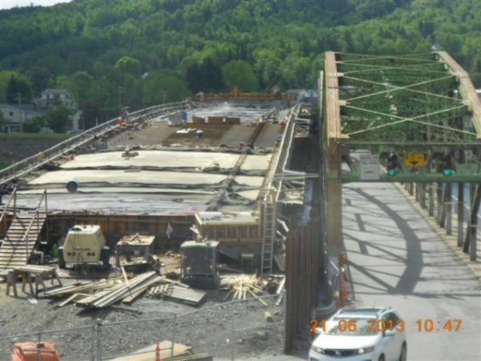
The Town of Fort Kent and MaineDOT have identified the replacement of the International Bridge between Fort Kent and Clair, New Brunswick as a high priority location for road and intersection improvements. The new four-span, steel-beam bridge will be 25 feet wider than the existing one and includes three in-river piers and two abutments. The multimillion-dollar contract is being shared evenly by Maine and New Brunswick and is anticipated to be completed in early summer 2015.

The project will:
- Construct a new bridge across the St. John River
- Construct a new access road to the bridge
- Add sidewalk on north side of Main Street
- Improve signage

St John Valley Scenic Byway Corridor Management Plan

Much like the Fish River Scenic Byway Corridor Management Plan, the recently completed St. John Valley Scenic Byway Corridor Management Plan also identified scenic and recreational resources that should be preserved and enhanced in the St. John Valley. The St. John Valley Scenic byway begins in Allagash and ends in Hamlin and utilizes Route 161, Route 1, and a portion of Route 162 and 1-A. In addition to identifying the dangerous areas due to low shoulders and poor geometrics, the CMP also identifies the importance of the Tour de la Vallee bike race.

Fort Kent Downtown Plan

The town of Fort Kent had two major fires in its downtown in a short period of time. Town planners took this loss as an opportunity to plan in the downtown and began revitalization efforts. One of the outcomes of this planning activity was the development of a Tax Increment Financing District (TIF) where funds generated from the Downtown TIF District may be used for public improvements, private improvements or to set up a revolving loan fund. Town planners also hired a downtown specialist to redesign the downtown. Part of this redesign effort includes making the area more bicycle- and pedestrian-friendly.

Existing Plans and Ordinances and Budgeting

Fort Kent does not currently have a bicycle and/or pedestrian plan. The 2012 Comprehensive Plan recommended applying for state and/or federal funds to construct a bike recreational trail called the Fish River Greenway. The plan made the following recommendations for sidewalks:
- Create a capital improvement plan that includes maintenance of sidewalks, curbs and crosswalks
- Provide crossing assistance for pedestrians on Main Street
- Create better signage near the school zones

Neither the subdivision ordinance nor the site plan review ordinance require a developer to consider bicycle or pedestrian needs when planning projects. The road design and construction ordinance only indicates that a developer must provide for a continuation of pedestrian traffic.

Existing Conditions

With a population of 4,097 (2010 US Census) and a land area of approximately 55 square miles, Fort Kent is a small town with a relatively large expanse of undeveloped land. Fort Kent has large undeveloped areas, rural residential areas, suburban residential neighborhoods, commercial/industrial areas and a central business district. Recent commercial growth is occurring primarily in the downtown and along the major transportation routes. Most of the commercial development has been small scale. Residential growth is occurring throughout Fort Kent with several large subdivisions occurring along Route 161 west of the downtown and Route 1 east of the hospital.

No clear boundary exists that neatly divides Fort Kent into built-up areas and rural areas. The geography of Fort Kent is such that development has occurred in a spider-like fashion along the relative lowlands of the community and along the river bottoms. More recently, residential development has spread to the higher elevations, such as Charette Hill, Violette Settlement and Third Avenue. The 2012 Comprehensive Plan update, however, delineates future land use goals with well-defined rural and built-up areas. The plan suggests that areas defined as “mixed use,” “urban residential” and “downtown” would be the highest priority for sidewalks and other pedestrian facilities. Areas outside of these land use categories, including commercial designations and residential growth areas, would be likely areas for creating safe access for bicycles and pedestrians as possible.

Conditions-Sidewalks
Unfortunately, Fort Kent does not have a detailed, online inventory of sidewalk issues. The Bicycle and Pedestrian Advisory Committee has identified areas where sidewalks were in disrepair, interrupted, damaged or in other ways unsafe for persons walking, running or bicycling. The sidewalk inventory identifies several kinds of challenges that particularly affect persons using wheelchairs, but also identifies many that are impediments to all travelers:
- Crosswalks that are inaccessible or poorly marked
- Cuts in paving - sudden drop-offs or step-ups
- Damaged paving
- Debris including sand, gravel, sand, snow and water
- Drainage grates
- Gaps where sidewalks end forcing people into the roadway
- Obstructions including utilities, vegetation, fences, walls, signage and parked cars
- Slope of sidewalk side to the other or in the direction of travel
- Substandard width

In many cases these kinds of problems overlap. For example, a poorly designed drainage grate accumulates debris, causes undermining of existing sidewalks which results in sudden changes in the surface.

Fort Kent’s Public Works Department works annually to maintain sidewalks. Pedestrians are served by a 5.8 mile network of sidewalks located in the more densely developed parts of town and 6.6 miles of trails and paved routes. Recent sidewalk maintenance costs were approximately $15,000. Continued maintenance is necessary and reconstruction should occur on up to 25 percent of the network. To encourage bicycle use, the town and schools provide bike racks at several locations. The trail network available for bike use includes the 6.6 miles available for pedestrian use; none of this includes delineated bicycle lanes, however, and this figure does not include the Heritage Trail, which connects several towns in the area, and is commonly biked.

The biggest area of concern was located on Market Street and East Main Streets where the popular “Mills” walk is utilized by residents. Generally speaking sidewalks are in good condition; however, there are areas where the sidewalks end abruptly or change sides of the street. The area near the Heritage Trail (Market Street) has a crossing marked along with electronic signage where the sidewalk ends on the west side of the road and crosses to the east. However further south, the sidewalks abruptly end near Doris’ Café and there are no paved shoulders further south on Route 161. There is also no crossing located at New Bridge, the Fish River bridge. The Fort Kent Public Works department did stripe the shoulders for the first time in 2013 and the marking has been useful in delineating walking areas and shoulders. And finally, with the creation of the new Riverside Park entrance at River Street, a new pedestrian crossing will need to be delineated.

A second area of concern is Pleasant Street near the University of Maine at Fort Kent. Sidewalks are located on the east side of the road and crossings are marked at two locations near the university and high school. However, the committee noted that university students living in the Lodge or utilizing the gym on the west side of Pleasant Street tend to cross at random locations. This is particularly true at meal times when students are walking to the main campus from the dormitory.

One final area of concern was identified. As stated previously, traffic in the downtown is varied with shoppers, heavy haul trucking, bicycles and pedestrians. With the closure of Elm Street, town officials believe that Hall Street will see significant increases in traffic through residential neighborhoods. At the present time there is no crossing located at the intersection of Hall and Main Streets. In general, pedestrians tend to cross West Main Street throughout the entire downtown area.

Fort Kent Sidewalk Inventory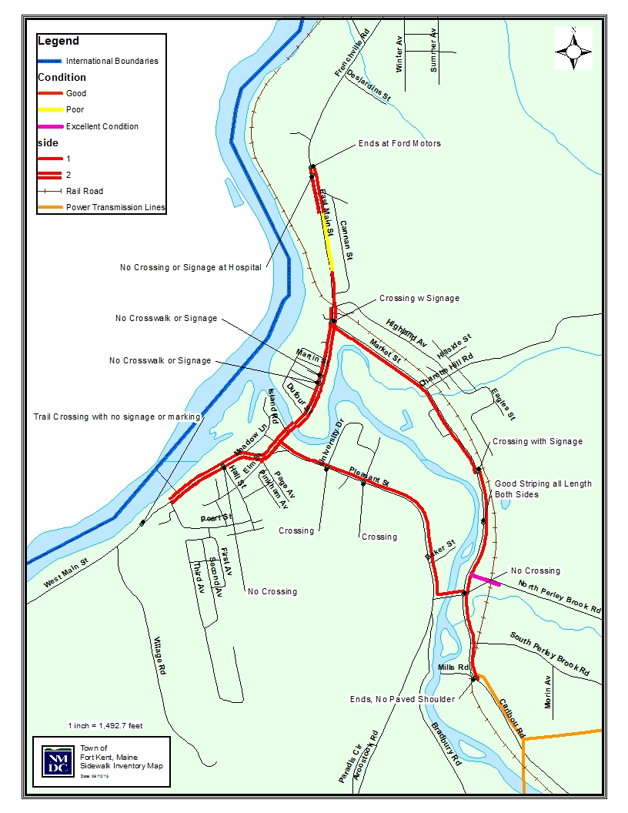
Safety Concerns

A review of the 2012 comprehensive plan identified several dangerous locations along local roads. These may include curves, blind hills or driveways, unprotected embankments, solar glare, shaded areas and other hazards. There are two designated “high crash locations” including the intersections of East Main, Market and Soucy Streets and one location along the Frenchville Road (US Highway 1) where the road is shaded in winter by a steep slope along the south edge of the highway. Four local road segments were identified as lacking guardrails where the road shoulder drop-off is severe and other design characteristics create notable safety concerns. The Klein Road bridge/culvert, two bridge/culvert locations on North Perley Brook Road, including one east of the Blaine School Road intersection and one northeast of the intersection and the curve west of the Klein Road on South Perley Brook Road, all require guardrails to improve safety. Another safety concern is the site distance/visibility at the intersection of Armory Road and Pleasant Street near the community high school, where vegetation should be removed.

Pedestrian safety issues were also identified. Speeding in the school zone on Pleasant Street has been an issue. While enforcement has been stepped up, the zone lacks the proper signage to indicate the school zone limits. Pedestrians and bicyclists using the multi-use Heritage Trail may be at risk from motorized traffic depending on time of day (light conditions) and speed. A biathlon training route on South Perley Brook Road poses a safety concern because of speed and lack of road shoulder and signage.

Traffic accident information was gathered from MaineDOT Traffic Engineering Accident Records to determine if there were any serious issues with traffic safety along the length of the corridor. During the study period of January 2006 to December 2012, there were a total of 502 accidents along the Route 161/Route 1/Route 11 corridor. Of those, there were two fatal accidents involving two fatalities. One fatal accident was recorded on US Route 1 and the other on Route 11. The Route 11 accident included a pedestrian. There were no reported accidents where pedestrians were identified on US Route 1 or 161 for the period. Three reported pedestrian accidents were recorded on Route 11.

Route 161 had the highest number of accidents at 241 followed by US Route 1 (213), and Route 11 (48). A review of the data does not indicate any one location where there was a higher than expected number of accidents. Crash rates in Fort Kent are highest in the most heavily congested areas. However those accidents that are considered the most severe are higher where traffic speeds are at their maximum outside of the built-up downtown area.

Goals, Objectives, Strategies

Pedestrian/Bicycle Vision for Fort Kent

Fort Kent’s downtown has an extensive sidewalk system but major transportation corridors such as Routes 1 east of Main Street, Route 161 west to St. John Plantation and south to New Canada, and Route 11 south to Wallagrass, lack pedestrian and bicycle facilities. With the exception of limited areas of paved shoulders, bicycle facilities are absent, requiring bicyclists of all abilities to share most roads with motor vehicles. Even with this important safety consideration, roads are still attractive to a growing number of bicyclists in the community and those visiting the Fort Kent area. This may become even more prevalent as marketing for the St. John Valley and the Fish River Scenic Byways increases and regional events attract additional visitors. For these reasons and others, improved pedestrian and bicycle facilities are important for Fort Kent’s future.

Goals, Objectives and Strategies

Goal 1: Safety: Provide safe routes for pedestrians.

Objective: Create and maintain pedestrian crosswalks in key locations.
Strategies

- Continue to work with the town council, planning board, citizens and the business community to identify areas of critical need as they emerge and as pedestrian traffic increases.
- Improve existing pedestrian crossing locations in the downtown and on Routes 1, 161, and 11 especially near primary and secondary schools, the University of Maine at Fort Kent, public facilities, Riverside Park, and in the downtown area.
- Create new pedestrian crossings wherever new sidewalks are developed.
- Develop a solution to allow walkers to safely stay on the river side of Market Street between the Heritage Trail and Bridge Street. Potential solutions include paint delineation on the roadway or narrowing or shifting lanes to allow a separate sidewalk to be constructed.
- Create new pedestrian crossings at the following locations:
- Intersection of Hall and Main Street
- Intersection of Heritage Trail and Pleasant Street
- Intersection of Market Street and Heritage Trail
- Town office across Main Street to the international bridge
- McDonald’s and Main Street
- Improve sidewalks at the following locations;
- Market Street
- From railroad tracks on West Main Street to Northern Maine Medical Center.

Objective: Ensure safe routes between neighborhoods and along routes with significant bicycle and pedestrian usage.
Strategies

- Increased traffic enforcement (speed) in the entire Elm Street area.
- Increased traffic enforcement, given changing traffic patterns in the Elm, High, Hall, Pearl Street areas.
- Install paved shoulders on local roads where feasible when they are slated for reconstruction or major improvements.
- Request that MaineDOT install paved shoulders wherever feasible when it schedules state and state-aid roads for reconstruction or significant improvements. Especially as new home construction occurs on Route 161 west of the downtown and on Route 1 east of Northern Maine Medical Center.
- Sweep paved road shoulders at least annually and more frequently during high use periods between May and October.

Objective: Use signage and other traffic calming measures to enhance safety on key routes.
Strategies

- Install “bike route” signs wherever paved shoulders satisfy state standards.
- Install “bike route” signs around the Fort Kent Mills loop area.
- Install pedestrian and bike signage indicating crosswalks and the presence of bicyclist and pedestrians at the following locations
- On Main Street near the Hall Street intersection.
- At UMFK
- At Pleasant Street/ Heritage Trail intersection.
- At Market Street/Heritage Trail Intersection
- Near the Fort Kent Mills bridge (New Bridge) on Market Street

- Consider installing traffic calming devices to allow safer pedestrian crossings on Route 161, 11, and 1, and elsewhere near the schools, public facilities and similar areas.
- Install “Share the Road” signage on US Route 1 eastbound towards Frenchville, Route 161 southbound toward New Canada, and Route 11 southbound toward Wallagrass.

Goal 2: Education and Awareness: Educate the public about bicycle and pedestrian facilities and issues, the health benefits of walking and biking and facilitate easy access to information.

Objectives Build awareness of existing bicycle/pedestrian assets.
Strategies

- Continue to support the efforts of the Bicycle and Pedestrian Advisory Committee
- Create and maintain a publicly accessible website or link to the town website with local bicycle/pedestrian information and maps.
- Develop and install signage for trails and walking/biking routes including:
- Signage delineating trail systems at UMFK and 10th Mountain Outdoor Center. Signage should also include a better delineation of walking trails at the 10th Mountain Outdoor Center trail system.
- Signage delineating trail system at Riverside Park and along the St. John River near the Blockhouse.
- Delineating trail system around the Fish River including the area on Market Street between McDonalds and the Heritage Trail intersection.

Objective: Provide educational programs about bicycle/pedestrian safety.
Strategies

- Encourage elementary, middle and high schools to promote bicycling and walking to school and embrace Maine Safe Routes to School programs.
- Engage the Healthy Maine Partnerships, Bicycle Coalition of Maine and other organizations to assist with formation of bicycle clubs and/or participation in existing clubs at the middle and high school levels.
- Engage the Healthy Maine Partnerships, Power of Prevention, Bicycle Coalition of Maine and other organizations to conduct bike and walking events at schools including but not limited to:
- Bike rodeos
  - Bike safety classes
  - Bike to school week
  - “Biking School Bus” program
  - “Walking School Bus” program
  - Walk to Work events

Objective: Hold public events that encourage use of bicycle and pedestrian infrastructure.
Strategies

- Develop and distribute a map of existing facilities within Fort Kent.
- Locate bike racks in destination areas in the downtown, schools and the recreation facilities.
- Partner with the recreation department, other local recreation organizations and other organizations to hold bicycle and pedestrian friendly events.

Goal 3: Connectivity & Infrastructure: Modify the transportation infrastructure to provide safe bicycle/pedestrian access to and between significant destinations and neighborhoods and enhance connections to the network of other bicycle/pedestrian facilities.

Objectives: Create routes to key destinations.
Strategies

- Complete trail system designated as the Fish River Greenway which includes:
- Completing trail development on southwest side of the Fish River near the high school.
- Better delineation of the trail system behind UMFK at Crocker Beach to Pleasant Street.
- Signage and delineation from Pleasant Street to West Main Street, across Fish River Bridge and along East Main Street.
- Request MaineDOT review the design of the Fish River Bridge to make more bicycle and pedestrian friendly.
- Install benches, lights, and signage on the portion of the trail located southwest of Market Street to the Heritage Trail.
- Develop of solution to allow walkers to safely stay on the river side of Market Street between the Heritage Trail and Bridge Street. Potential solutions include paint delineation on the roadway or narrowing or shifting lanes to allow a separated sidewalk to be constructed.

- Develop signage at Lonesome Pine detailing the trail system between Lonesome Pines, UMFK, and the 10th Mountain Outdoor Center trails.
- Upgrade the trail system along Dufour Street to Riverside Park.
- Upgrade the trail system along the levee located behind West Main Street. Upgrades should include signage, benches, and lighting.
- Delineate trail system in the neighborhoods along Hall, High, Pinkham and Page Street, to UMFK and to the schools and recreational facilities.
- Develop an off-road connection between the subdivisions located along the St. John River (Route 161) and the Heritage Trail as well as the subdivisions on Route 1 and the downtown.
- Signage and marking from the town office along Pearl Street to the Lonesome Pine Trails system. Marking should include signage indicating that pedestrians/bicyclists are present and directing pedestrians/bicyclists to trail system located at Lonesome Pines.
- Develop a paved accessible trail connecting the Riverside Park trails to the community mural at the entrance to the park.

Goal 4 Develop town-wide policy for bicyclist and pedestrian activities,
Objective: Update plans/regulations/guidelines, as appropriate, to support and promote walking and biking.
Strategies
- Encourage the development of a Complete Streets policy.
- Develop a sidewalk usage policy that includes the use of bicycles on sidewalks.
- Encourage the development of bike lanes.
- Work with the Downtown Committee to ensure that bicycle and pedestrian facilities are part of the downtown design.
- Encourage consideration of pedestrian and bicycle access as new housing and commercial units are developed.
- Maintain a standing town Bicycle and Pedestrian Advisory Committee to advise the town council.

Fort Kent Bicycle and Pedestian Potential Projects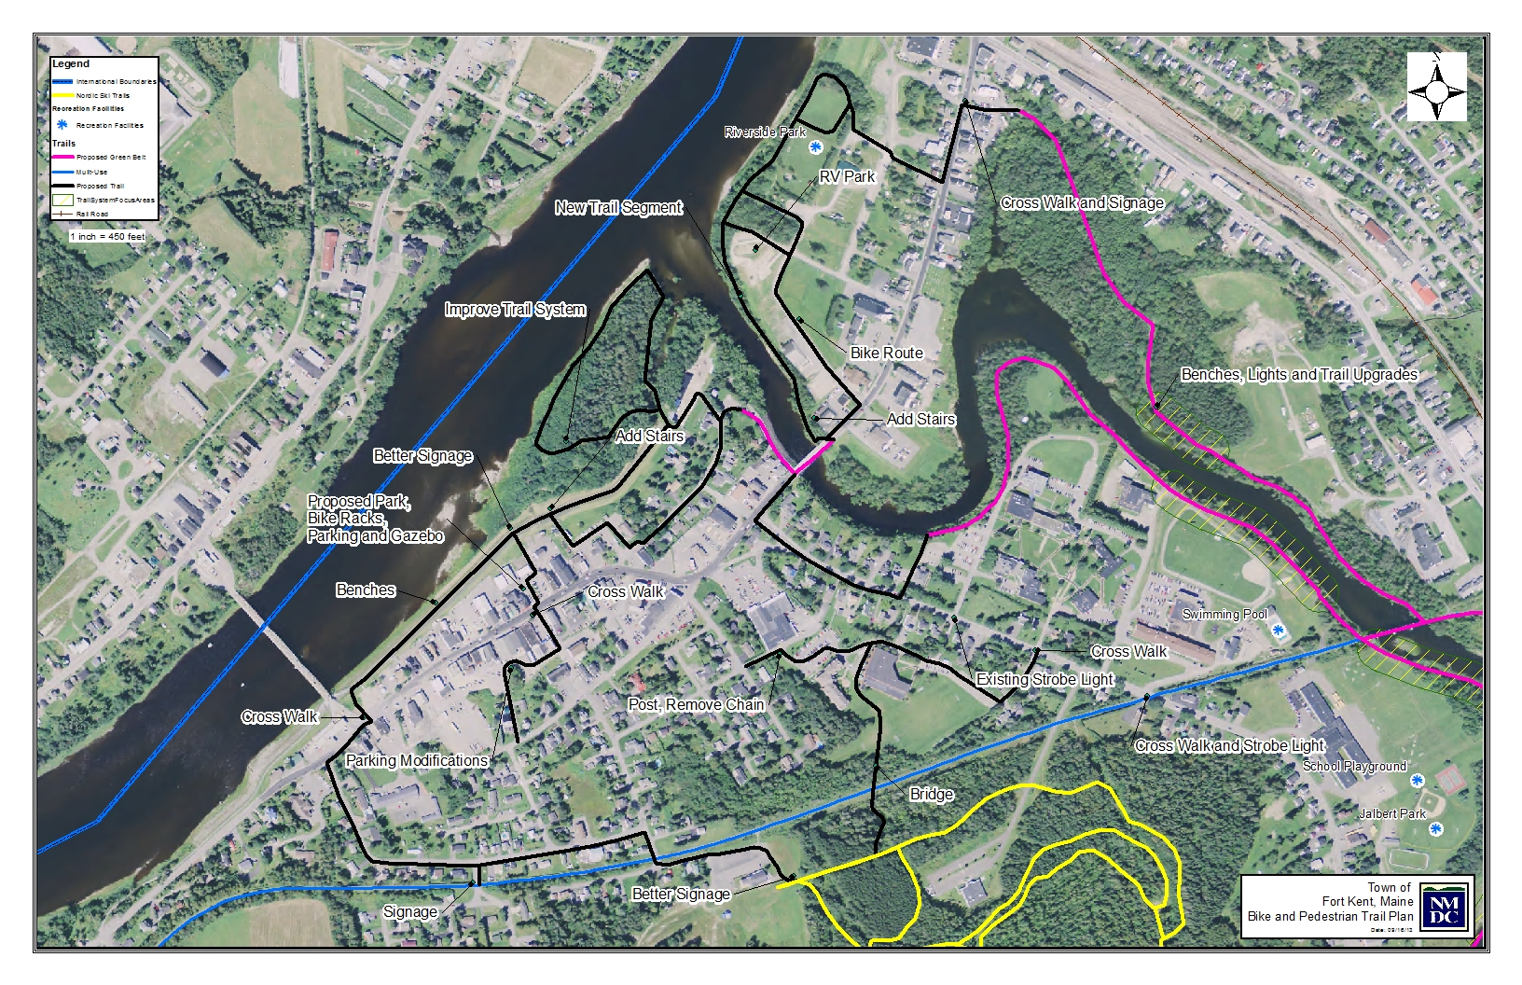

Proposed bicycle and pedestrian facilities and services

Turning goals, objectives and strategies into projects that can be implemented required one more step. Many potential projects are listed within this document, both in the coordinating section, the inventory of assets and issues and the goals, objectives and strategies. As the discussion progressed, the group determined that a high priority should be to improve bike and pedestrian trails and safety issues in the downtown. Many of the projects brainstormed were identified as connections to assets in the downtown including the Heritage Trail, Lonesome Pine Trails, 10th Mountain Outdoor Center, St. John and Fish Rivers, Riverside Park, and the Fish River Greenway. The group felt that other projects should be listed in the plan and completed as funding is obtained.

Criteria for Selecting Projects

The committee considered the following criteria in evaluating the list of project and policy proposals.

- Safety - The degree to which the existing condition poses a threat to public safety and the degree to which a proposed route or improvement will enhance public safety.
- Access - The degree to which a proposed route or improvement will provide or enhance access to and between significant destinations (e.g. schools, recreation facilities, parks, natural areas, major employers).
- Demand - The degree to which an existing route is used and degree to which a proposed improvement will result in increased use.
- Connectivity - The degree to which a proposed route or improvement will enhance connections within the larger network of bicycle/pedestrian facilities.
- Scenic/Cultural/Historic Values - The degree to which a proposed route or improvement will preserve, enhance or degrade the town's scenic, cultural and/or historic character.
- Economic Value - The degree to which a proposed route or improvement will preserve and enhance the economic vitality of the town.
- Coordination with existing plans, programs and projects

Project Proposals

High Priority Investments
Phase I

- Address current safety issues
  - Market Street sidewalks
  - UMFK crosswalks
  - New Fish River Bridge
  - Replace/repair broken bridges on the Island Trail and Jalbert Park trail
  - Link on Town of Fort Kent website for users to report trail/safety issues
  - Speed enforcement in areas with identified need
  - Pedestrian crossing signs at crosswalk
- Increase and improve signage – for new trail development and better awareness of current trail system
  - Island Trail – small kiosks and directional signs
  - Heritage Trail – directional signs, trail map
  - Riverside North - directional signs
  - Riverside South - directional signs, trail map
  - Riverside West - directional signs
  - Riverside Park- large kiosk, trail map
  - Hall Street - directional signs
  - Pleasant Street- directional signs
  - Market Street- directional signs
  - West Main Street- directional signs
  - East Main Street- directional signs
  - Levee Trail- directional signs
  - Fournier Biological Park- directional signs
  - Mills to Mountain trail- directional signs
  - Safe Routes to School trail- directional signs, pedestrian crossing signs
  - Jalbert Park trail- directional signs
  - Interpretive park near Jalbert Park- small kiosks and directional signs, trail map
  - Crocker Beach trail- directional signs
  - Better sign or kiosk location at Lonesome Pine to help people connect to the 10th Mountain trails, downtown trail map
  - Violette Settlement trail- directional signs

- Develop trail connections
  - Heritage trail to 10th Mountain Trails- Fournier Biological Park
  - New Riverside Park sidewalk to asphalt trail in lower Riverside Park
  - Blockhouse Trail to entrance of Island Trail
  - Heritage Trail to Main Street – Hall Street
  - Simpler temporary bridge design to access Island Trail
  - Jalbert Park trail to Interpretive park and associated bridges

- Increase awareness
  - Signage
  - Brochures
  - Painted trail lines on sidewalks
  - Town events
  - Chamber of Commerce website
  - Town of Fort Kent website

- Improve and maintain sidewalks and trails
  - “Mills loop” – improvement repairs for smother usage along East Main, Market, and Pleasant Streets.
  - Regularly maintain sidewalks that are shown on the trail map as being part of various loops
  - Restore the scalp surfaced trail from the Heritage Trail to the Jalbert Park Trail beside and behind the elementary school
  - Add a scalp surface to the interpretive park trails at the south end of the Jalbert Park Trail (on the site of the old town garage)
  - Add bike lanes where feasible
  - Maintenance to be performed by Public Works and volunteers recruited by the Fort Kent Bicycle/Pedestrian Advisory Committee

- Acquire materials
  - Trail maintenance equipment- brush saw, chainsaw, walk-behind bush-hog
  - Trail building equipment- mini-excavator
  - Bridge maintenance materials
  - Additional bike racks

- Continue searches for grant funding
  - MDOT Transportation Enhancement
  - BPL RTP Trail Grant
  - Davis Foundation
  - Fields Pond Foundation
  - Other appropriate grant sources
Phase 2

- New Trail Development for Greenway completion
- Trail development and picnic area on Fish River from bridge on E. Main St. to area behind Acadia Credit Union

Policies, Local Laws and Ordinances
Identify central walking area
Encourage bicycle and pedestrian infrastructure with new developments
Stop, look, listen warning signs at crosswalks

Next Steps:
- Town council adopts the Bicycle Pedestrian Plan
- Initiate process of drafting local bicycle and pedestrian policies
- Coordinate joint meetings between Bicycle Pedestrian Committee and Public Works Department to create a work plan and budget for priority projects
- Hold additional public informational forums on priority projects
- Identify funds and funding opportunities for construction of projects
  - State and Federal grants programs
  - Local matching funds
  - Private and voluntary contributions
- Apply for funding, when appropriate for projects
  - Safe Routes to Schools
  - Transportation Enhancement Grants
  - Multimodal funding – for bus stops and intermodal facilities
  - Municipal Project Request
- Preliminary engineering
- Construction engineering
- Marketing and publicity

