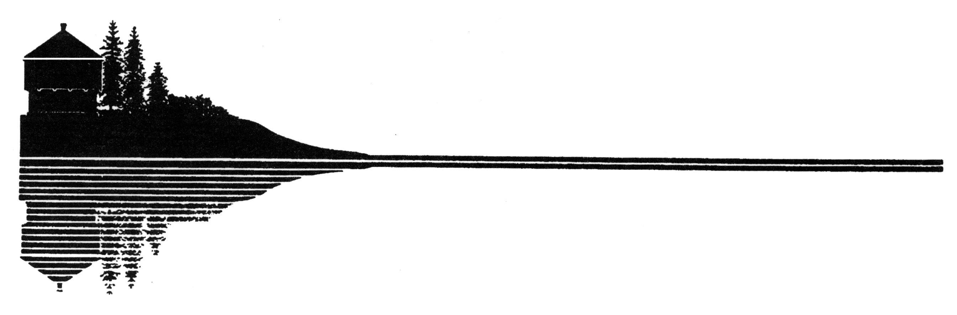 |  |  |  |  |  | Application for Trip Permit  For Perishable Products
Town of Fort Kent |  |  |  |  |  |  |  | * Public Works Department |  |  |  |  |  |  |  |  |  |  |  | * 416 West Main Street |  |  |  |  |  |  |  |  |  |  |  |  | * Fort Kent, Maine 04743
 | Insert Name Here |  |  |  |  |  |  |  |  |  |  |  |  |  |  | requests consideration for a Trip Permit, for the vehicle listed
below to operate on local roadways which have been posted with “HEAVY LOADS LIMITED” signs, under the provisions of Town of Fort Kent Restricting Vehicle Weight on Posted Ways Ordinance Section 7.
For each time any vehicle transporting bulk perishable products over seasonally closed ways must secure a Trip Ticket from the Town of Fort Kent. These trip tickets will be for hauling of perishable products by 5 axle or more combination vehicles and shall be limited to a combined weight of 80,000 pounds and may on occasion, be further limited by time, route and temperature. The Town of Fort Kent reserves the right to close any posted road to the hauling of perishable products in extreme circumstances. The Town of Fort Kent will have up to 72 hours to review the application.
The applicant understands:
1. |  | The weight limitation as indicated on the certificate, vehicle with load, does not apply when the closed sections of the highway are solidly frozen.
2. |  | The vehicles will be subject to weighing by the Maine State Police or the Fort Kent Police.
3. |  | The owner of any vehicle operating on any closed section of highway, the gross weight (vehicle and load) of which exceeds the weight indicated on the certificate will be in violation of any TRIP TICKET PERMIT ISSUED.
4. |  | A violation of the requirements on the PERMIT may lead to revocation.
5. |  | The PERMIT granted as a result of this application will be valid for the vehicle described below AND only on the date, time and roads listed on Trip Ticket.
This application is for the following vehicle:
Registration: |  |  |  |  |  |  |  |  |  |  |  |  |  |  | Make: |  |  |  |  |  |  |  |  |  |  |  |  |  |  |  |  |  |  |  | Year:
Vehicle ID #: |  |  |  |  |  |  |  |  |  |  |  |  |  |  | Registered G.V.W.
Empty Weight: |  |  |  |  |  |  |  |  |  |  |  | lbs |  |  | Commodity Transported:
Date: |  |  |  |  |  |  |  |  |  | Time: |  |  |  |  |  |  |  |  |  |  |  |  |  |  | AM |  |  |  |  | PM
Shipper:
Via Routes:
Vehicle Configuration (select only one)
 |  | 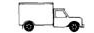 |  |  |  |  |  |  |  |  | 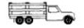 |  |  |  |  |  |  |  |  |  |  |  |  |  |  |  |  |  |  |  |  |  |  | 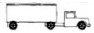
 |  | 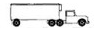 |  |  |  |  |  |  |  |  | 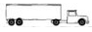 |  |  |  |  |  |  |  |  |  |  | 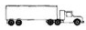 |  |  |  |  |  |  |  |  |  |  |  | 
Tire Size: |  |  |  |  |  |  |  |  |  |  |  |  |  |  | Use the most common tire size on axles other than the steering axle. All axles must have four tires
except for the steering axle which normally has two tires. Tire widths shall be based on the manufacturer’s rating.)
I will instruct all operators and employees transporting the above indicated commodity to comply with the provisions of
the Town of Fort Kent Restricting Vehicle Weight on Posted Ways Ordinance and of the TRIP PERMIT.
Signed by: |  |  |  |  |  |  |  |  |  |  |  |  |  |  |  |  | Title: |  |  |  |  |  |  |  |  |  |  |  |  |  |  | Date:
Company: |  |  |  |  |  |  |  |  |  |  |  |  |  |  |  |  |  |  |  |  |  |  |  |  |  |  |  | Phone: |  |  |  |  | (207) |  |  |  |  |  |  | -
Address:

